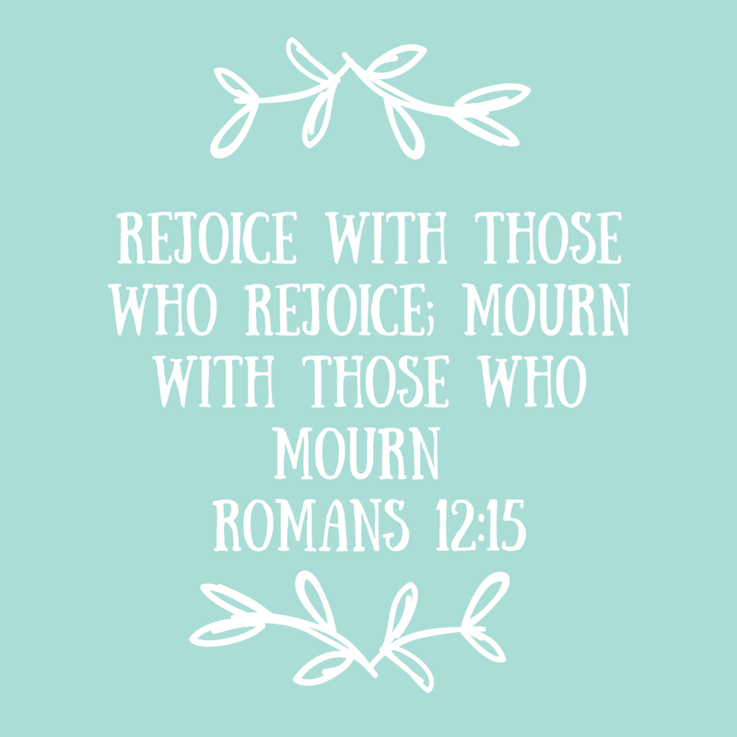

Dear Friend:

I am writing to you to ask for your participation in the #HonorAllMoms campaign.

This Mother’s Day let’s choose to love on ALL moms: the moms who have a precious baby they can hold in their arms, the moms whose sweet babies are in heaven, and the women struggling with infertility.

I started an online Christian support group for women who have experienced pregnancy loss. I am also working on a book that explores this sensitive topic and about cherishing the life that was conceived. I’ve spoken with hundreds of women about their loss and have found that Mother’s Day is one of the most dreaded days of the year.

Let’s change that. Let’s bring these women out of the shadows and into the light of love.

**Who are the moms who need extra love and support?**

• **The dear moms who have outlived one or more of their children**

They put in the sleepless nights, tackled the pile of never-ending laundry, and miss—more than anything—the sweet, sweet embrace of their precious child.

• **The invisible moms who have experienced pregnancy loss**

Their babies died in the womb, but reside in heaven. The terminology used to describe that trauma, “miscarriage” and ‘stillbirth,” are deceptively simple terms that imply a slight medical procedure. But it’s not a medical procedure; it’s the loss of a precious life. For some parents, this tragedy happens multiple times. And some of these women have no living children.

• **The hopeful women who yearn for nothing more than to be a mom**

But they battle infertility. Some have lost that fight. Now people constantly question, “Why didn’t you ever have kids?” Let’s pour some love on them.

The following page will provide you with more information about the #HonorAllMoms campaign. I am reaching out to religious organizations in hopes that we can make a statement of love and support. I do pray you will join us!

All the best,

Sarah Lewis Philpott, Ph.D

www.allamericanmom.net

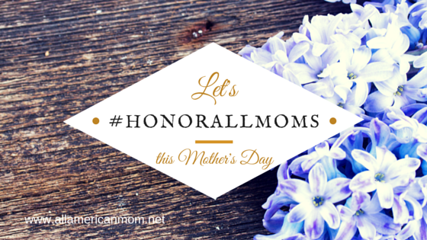







**Who Are We Honoring?**

* The women who have experienced the death of their child
* The women whose babies died in their wombs
* The women who possess the heart of a mother, but who have the disease of infertility

**How Individuals Can Honor All Moms:**

If you know one of these women, send her text message or a greeting card, make a phone call, envelope her in a hug, or send her flowers.

If you are at a loss for words simply write, “Hey, I know this must be a hard day for you. I just want you to know I’m thinking of YOU on this Mother’s Day. You are the Momma of a precious baby in Heaven. I love and cherish you.”

**How Places of Worship Can Honor All Moms:**

Places of worship might light a candle or a have a flower arrangement in honor of all the women whose babies are in heaven.

Write in the bulletin, “The flowers placed at the altar table are in honor of the mothers who have experienced the death of a child, in honor of all the mothers whose babies died in the womb, and in honor of the women whose hearts’ desire was to be a mom. We love you and honor you this Mother’s Day.” Or simply write, “The candles lit in the sanctuary are in honor of all the moms with babies in heaven.”

**Why Are We Honoring All Moms?**

* Helps families heal. Pregnancy loss should not be a shameful secret.
* Places value on the sanctity of life. Life begins at conception.
* Reaffirms the biblical basis that babies lost in the womb are in heaven.
* Cherishes the life that God allowed to be conceived.

**How Can You Spread the Message?**

* Visit the following link and share the blog post on social media http://allamericanmom.net/?p=294
* Use the hashtag #HonorAllMoms
* Email this letter to your church and contacts
* Write a message of support on your social media

**Will you Join Us?**

Allamericanmom.net | @SarahLPhilpott | [sarahlewisphilpott@gmail.com](mailto:sarahlewisphilpott@gmail.com)

Please search: **Loved Baby Christian Miscarriage Support** on Facebook to find our support groups.







**#HonorAllMoms**

Mother’s Day Campaign